PROJECT REPORT FOR

Foundations of Artificial Intelligence

College Club Event Recommendation & Timetable Planner

A PROJECT REPORT

Submitted by
2116240701025 -Akash M
2116240701077 – Bharath J


October, 2026

BONAFIDE CERTIFICATE

Certified that this project report “college club Event Recommendation & Timetable Planner” is the bonafide work of “Akash M (240701025) & Bharath J (240701077) ” who carried out the project work under my supervision.

SIGNATURE OF THE FACULTY INCHARGE

Submitted for the Practical Examination held on

SIGNATURE OF THE INTERNAL EXAMINER

TABLE OF CONTENTS

CHAPTER NO. | TITLE | PAGE NO.
 | ABSTRACT | 4
1 | INTRODUCTION | 5
2 | LITERATURE REVIEW | 7
3 | PROPOSED SYSTEM | 9
 | 3.1 ARCHITECTURE DIAGRAM | 11
4 | MODULES DESCRIPTION | 12
 | 4.1 MODULE 1 | 12
 | 4.2 MODULE 2 | 13
5 | IMPLEMENTATION AND RESULTS | 15
 | 5.1 EXPERIMENTAL SETUP | 15
 | 5.2 RESULTS | 16
6 | CONCLUSION AND FUTURE WORK | 19
7 | REFERENCES | 20

ABSTRACT:

The College Club Event Recommendation & Timetable Planner is a web-based application designed to help students identify suitable college club events based on their interests, skills, and academic timetable. The system provides a centralized platform for students to explore club activities and for administrators to manage clubs, events, schedules, and related information.
Students can maintain their profiles, specify their interests, and enter their weekly class timetable. The system evaluates event details, student preferences, available time slots, and timetable constraints to generate suitable event recommendations. A Rule-Based Expert System using predefined IF–THEN rules is used to determine whether an event satisfies the required conditions.
The system also includes timetable conflict detection to prevent recommendations for events that overlap with scheduled classes. Events scheduled outside the permitted college hours, from 8:00 AM to 5:00 PM, are excluded from recommendations and eligible-event counts. The application is designed using HTML, CSS, and JavaScript for the frontend, Python Flask for backend processing, and SQLite for database management.
The proposed system aims to reduce manual effort in searching for college activities, improve event discovery, and provide an organized and explainable recommendation process. By combining student preferences with timetable validation, the application helps students identify relevant club events without disturbing their regular academic schedule.

INTRODUCTION

College clubs play an important role in helping students develop technical knowledge, communication skills, leadership qualities, creativity, and teamwork. Various clubs organize workshops, technical competitions, seminars, cultural programmes, coding events, and other extracurricular activities. Participating in these events allows students to gain practical experience and improve their overall academic and professional development.
However, students often face difficulties in identifying suitable club events because information may be distributed across multiple platforms, announcements, and student groups. It can be challenging to find events that match their interests and skills while also fitting into their academic timetable. Students may accidentally select events that overlap with their classes or take place outside the permitted college hours.
The College Club Event Recommendation & Timetable Planner is a web-based application proposed to address these challenges. It provides a centralized platform where students can maintain their profiles, enter their weekly class schedules, explore college clubs, and receive recommendations for suitable events. Administrators can manage club information, publish event details, and maintain event schedules.
The system uses a Rule-Based Expert System as its Artificial Intelligence approach. The recommendation engine evaluates facts such as student interests, skill preferences, event categories, class schedules, and event timings. Predefined IF–THEN rules are applied to determine whether an event satisfies the required conditions for recommendation.
The system also performs timetable conflict detection. When an event overlaps with a student's scheduled class, the event is excluded from that student's recommendations. Similarly, events that begin before 8:00 AM or end after 5:00 PM are excluded from recommendations and eligible-event counts. These restrictions help ensure that recommended activities fit within the permitted college schedule.
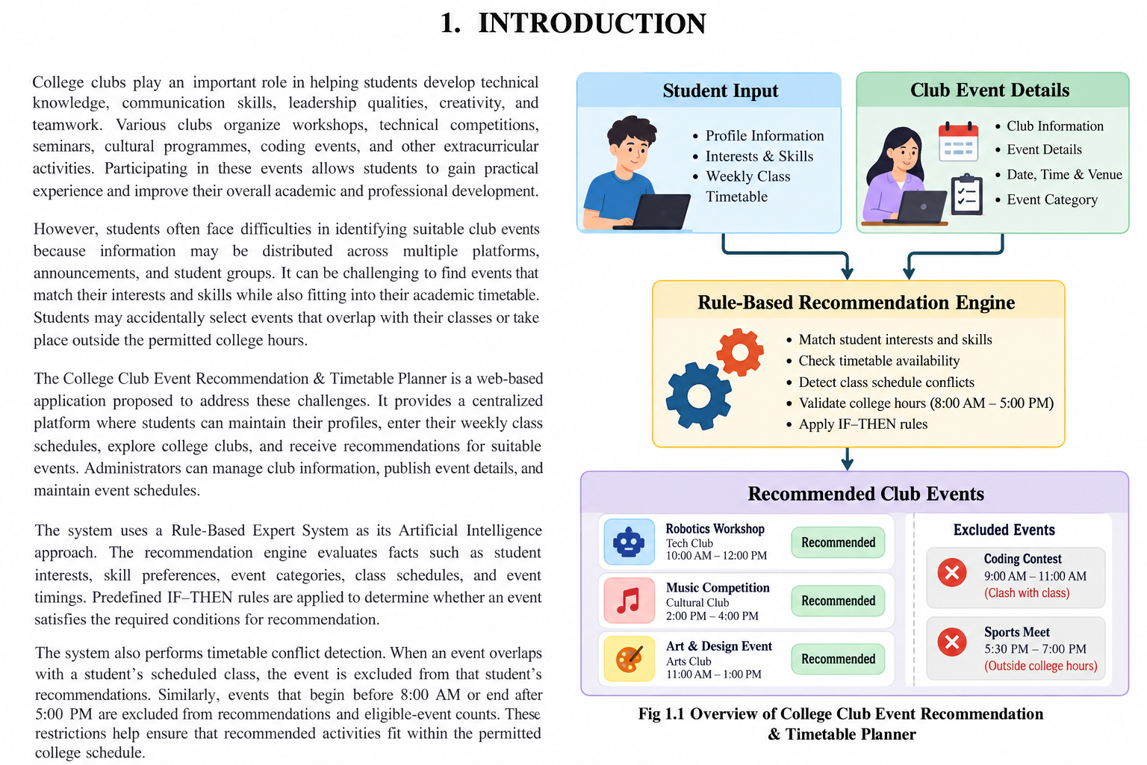
Fig 1.1 Forward Chaining Algorithm

LITERATURE REVIEW

2.1 Rule-Based Expert Systems for Team Formation
Event recommendation systems help users discover activities based on their preferences, interests, and requirements. Such systems can use information about event categories, user profiles, and event schedules to identify relevant activities. In a college environment, these techniques can help students discover technical workshops, cultural programmes, seminars, competitions, and other club events that match their interests.
The proposed project applies this concept to college club activities by considering student preferences together with timetable availability.
2.2 Timetable Management and Scheduling
Timetable management systems are used to organize academic schedules and identify available time periods. Scheduling constraints are important because students must attend their classes while participating in extracurricular activities. An event that overlaps with a scheduled class is not suitable, even if the event matches the student's interests.
The proposed system incorporates timetable conflict detection to compare event timings with the student's academic schedule. This helps ensure that recommended events fit into the student's available time.
2.3 Rule-Based Expert Systems
Rule-Based Expert Systems represent knowledge using predefined IF–THEN rules. These rules evaluate known facts and derive decisions according to specified conditions. For example, if an event matches a student's interests, falls within the permitted college hours, and does not overlap with a class, it can proceed to the recommendation stage.
The proposed system uses this approach to validate event eligibility and timetable compatibility. The rule-based method provides transparent decisions because the conditions responsible for recommending or excluding an event can be identified.
2.4 Research Gap
Basic event listing platforms allow students to browse activities, while timetable systems focus primarily on academic schedules. These functions do not necessarily provide a combined method for recommending club events according to personal interests and class availability.
The proposed College Club Event Recommendation & Timetable Planner combines event discovery, student preferences, timetable conflict detection, and college-hour restrictions in a single web application. It aims to provide more useful recommendations by evaluating both student interests and scheduling constraints.

PROPOSED SYSTEM

The proposed College Club Event Recommendation & Timetable Planner is a web-based application designed to simplify the process of discovering suitable college club activities. The system integrates student profile management, timetable management, club and event administration, and a rule-based recommendation engine.
Students can create profiles, select their interests and skills, and enter their weekly class timetable. The system retrieves available club events and evaluates them using predefined rules. Event timing, class conflicts, preference matches, and applicable eligibility conditions are considered during the recommendation process.
The Rule-Based Expert System evaluates facts such as event category, student interests, event start time, event end time, and class availability. Events that violate mandatory scheduling constraints are excluded before preference-based recommendations are generated.
The system also provides an administrative interface for maintaining club information and event schedules. This ensures that students can access event details through a centralized platform.
Major Components
1. Student Profile Module
- Student registration and login.
- Profile information management.
- Interest and skill selection.
- Storage of student preferences.
2. Timetable Management Module
- Entry or upload of weekly timetable information, depending on the implemented features.
- Storage of class days and time intervals.
- Identification of free periods.
- Validation of timetable information.
3. Club and Event Management Module
- Creation and modification of club information.
- Addition and updating of event details.
- Management of event dates, timings, categories, and venues.
- Validation of event schedules.
4. Rule-Based Recommendation Module
- Collection of student and event facts.
- Application of predefined IF–THEN rules.
- Evaluation of interest and skill matches.
- Generation of eligible event recommendations.
5. Timetable Conflict Detection Module
- Comparison of event timings with class intervals.
- Exclusion of events that overlap with classes.
- Validation of the 8:00 AM–5:00 PM college-hour restriction.
- Prevention of invalid events from appearing in recommendations and eligible-event counts.
6. Results and Notification Module
- Display of suitable club events.
- Presentation of event details and recommendation reasons.
- Display of available time slots.
- Optional reminders for selected events, if implemented.

ARCHITECTURE DIAGRAM
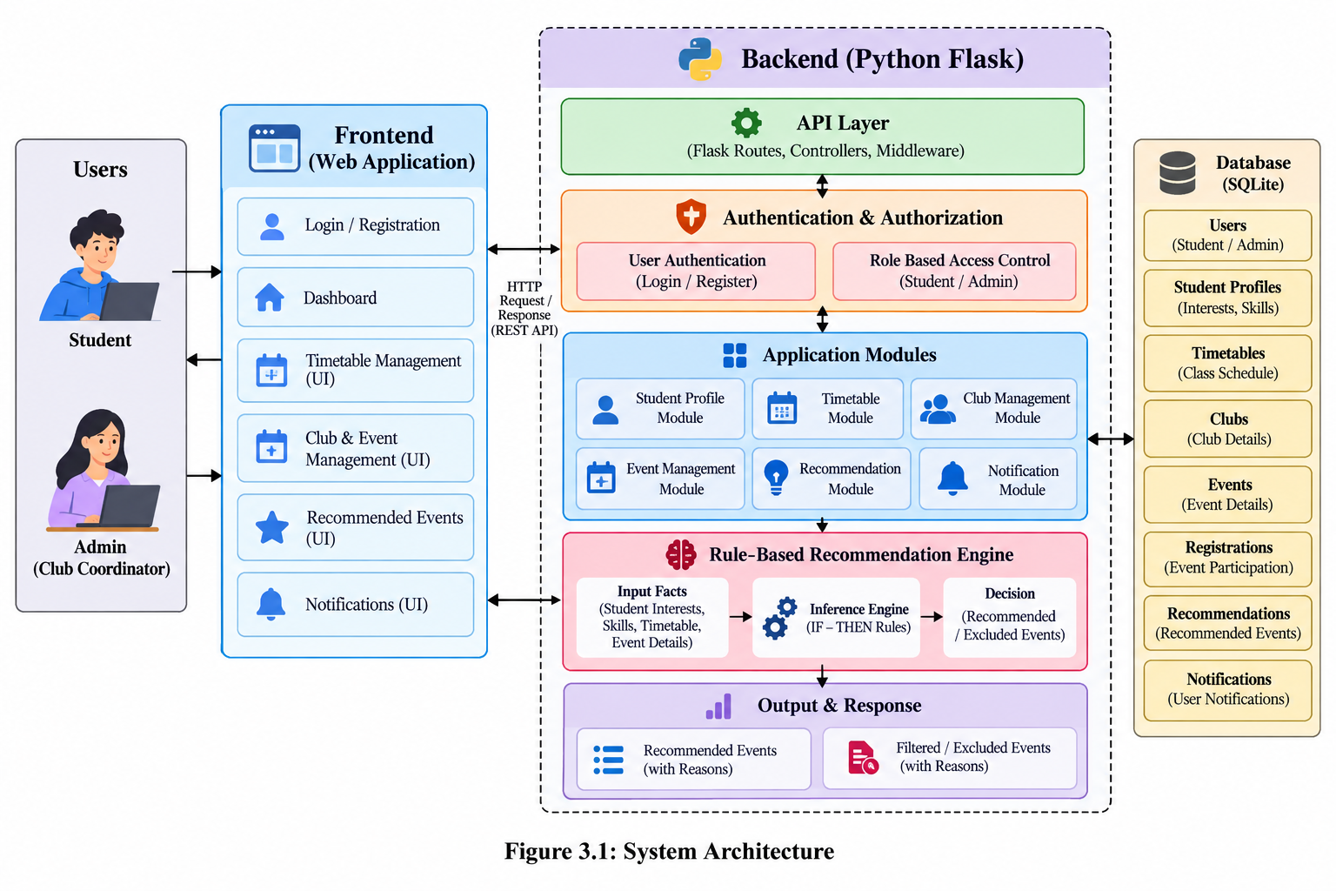
Figure 3.1: System Architecture

4. MODULES DESCRIPTION

College Club Event Recommendation & Timetable Planner is organized into modules that work together to provide an organized event discovery and scheduling environment. The student module manages profiles, preferences, and academic timetables, while the event management module maintains club and event information. The recommendation module evaluates event eligibility using predefined rules and timetable constraints.

4.1 MODULE 1 – STUDENT PROFILE AND TIMETABLE MANAGEMENT MODULE

The Student Profile and Timetable Management Module provides the primary interface for students. It allows students to access their accounts, maintain personal preferences, and enter their weekly academic schedules. The profile information is used to identify events that match the student's interests and skills.

The timetable component stores class days, start times, and end times. This information is used to determine whether a student is available during an event. Timetable information must be validated before being used by the recommendation engine.

Main functions:

Student registration and login.

Student profile management.

Interest and skill selection.

Weekly timetable entry or upload, depending on the implemented interface.

Timetable validation.

Identification of available time slots.

Display of suitable event recommendations.

4.2 MODULE 2 – CLUB AND EVENT MANAGEMENT MODULE

The Club and Event Management Module maintains information about college clubs and their activities. Administrators can add new clubs, update existing details, and publish events with the required schedule information.

Each event may include its title, description, club name, category, date, start time, end time, and venue. The system validates event timing before allowing an event to be treated as eligible for recommendation.

Main functions:

Club creation and information management.

Event creation and modification.

Event category and description management.

Event date and time validation.

Publication of eligible event details.

Maintenance of event information in the database.

4.3 MODULE 3 – RULE-BASED EVENT RECOMMENDATION MODULE

The Rule-Based Event Recommendation Module is responsible for identifying suitable activities for students. It collects facts from student profiles, academic timetables, and event records. These facts are evaluated using predefined IF–THEN rules.

For example, if an event matches a student's interest, does not overlap with any scheduled class, and falls within the permitted college hours, the event can be considered for recommendation. If a mandatory condition is not satisfied, the event is excluded.

Main functions:

Collection of student preference information.

Evaluation of event categories and interests.

Application of IF–THEN rules.

Validation of event eligibility.

Ranking or grouping of eligible events.

Generation of understandable recommendation reasons.

4.4 MODULE 4 – TIMETABLE CONFLICT DETECTION MODULE

The Timetable Conflict Detection Module ensures that recommended events do not interfere with students' academic schedules. It compares event time intervals with class time intervals for the same day.

When an event overlaps with a scheduled class, the system excludes it from the student's recommendations. The module also checks whether the event begins before 8:00 AM or ends after 5:00 PM. Events violating this restriction must not appear in recommendations or eligible-event counts.

Main functions:

Comparison of event and class intervals.

Detection of overlapping schedules.

Identification of available time periods.

Validation of college-hour restrictions.

Exclusion of invalid event recommendations.

Support for accurate recommendation results.

5. IMPLEMENTATION AND RESULTS

The College Club Event Recommendation & Timetable Planner is designed as a web-based application that integrates student profile management, event administration, timetable validation, and rule-based recommendations.
The frontend is developed using HTML, CSS, and JavaScript to provide the user interface. Python Flask is used for backend processing, request handling, timetable validation, and execution of the recommendation rules. SQLite is used to store student accounts, profile information, academic timetables, clubs, and event records.
The recommendation engine evaluates events against student preferences and scheduling constraints. Events outside the permitted college hours or overlapping with classes are excluded before the final recommendation list is displayed.
The implementation should be tested using different scenarios, including valid events, overlapping events, events outside college hours, and events that match student interests. Actual screenshots and test results should be included in the final report after testing the application.

5.1 Experimental Setup
The application uses the following technologies:
- Frontend: HTML, CSS, JavaScript.
- Backend: Python Flask.
- Database: SQLite.
- AI technique: Rule-Based Expert System.
- Scheduling validation: Time-interval comparison and constraint checking.
The following scenarios can be used to test the system:
- A student receives an event recommendation that matches their interests and free time.
- An event overlapping with a class is excluded.
- An event beginning before 8:00 AM is excluded.
- An event ending after 5:00 PM is excluded.
- An event that fits the student's complete free interval passes the timetable check.
- An event matching a student's interests is prioritized when all mandatory conditions are satisfied.
- An incomplete timetable triggers a validation message or prevents an unverified recommendation.

5.2 Results
The results section should contain actual screenshots captured from the completed application. Suggested figures include:
- Figure 5.2.1 – Student Login Page.
- Figure 5.2.2 – Student Dashboard.
- Figure 5.2.3 – Timetable Management Page.
- Figure 5.2.4 – Club and Event Management Page.
- Figure 5.2.5 – Recommended Events Page.
- Figure 5.2.6 – Timetable Conflict Detection Result.
- Figure 5.2.7 – College-Hour Validation Result.

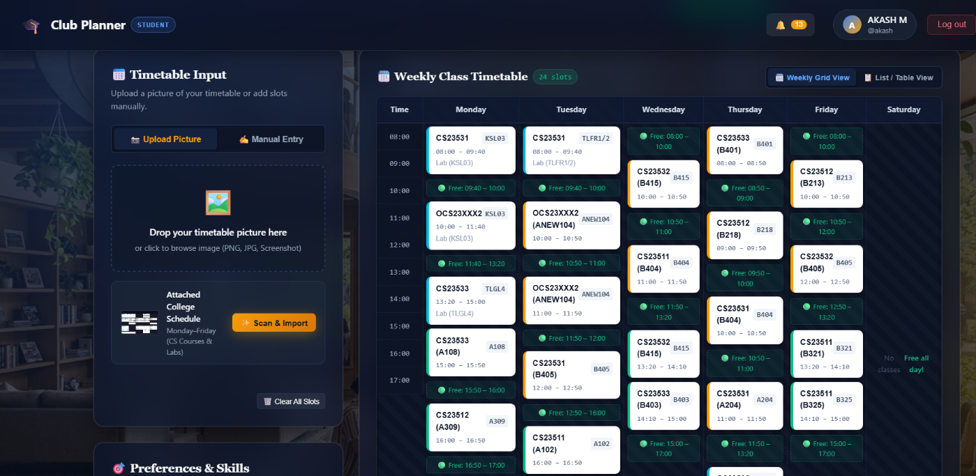

Figure 5.2.2: Timetable Management Page

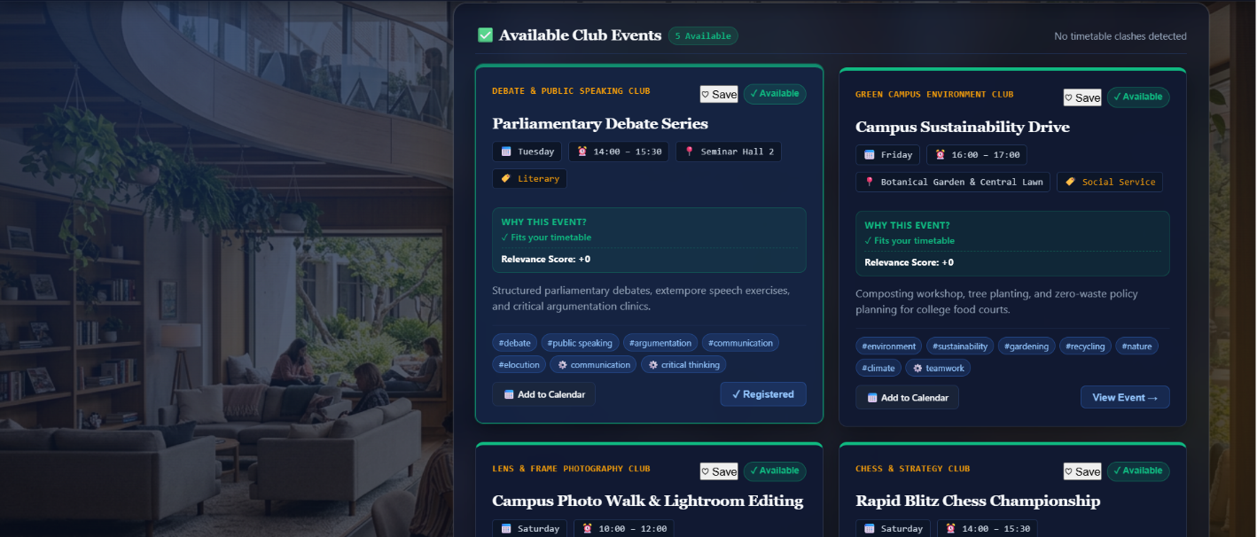

Figure 5.2.3: Recommended Club Events (Results) Page

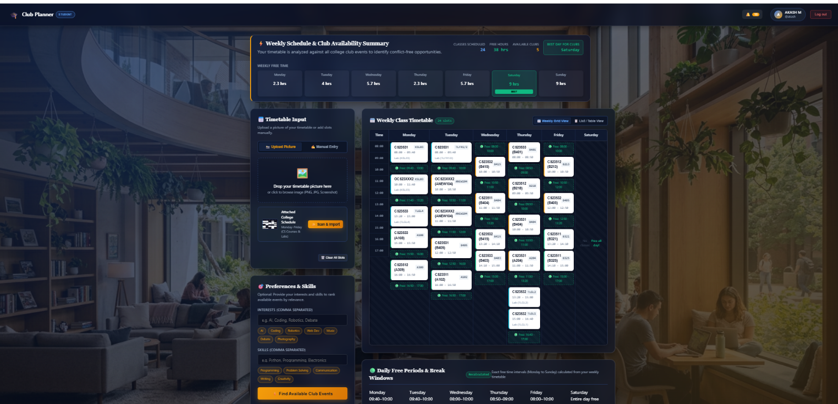

Figure 5.2.3:Student Dashboard

6. CONCLUSION AND FUTURE WORK

6.1 Conclusion

The College Club Event Recommendation & Timetable Planner is a web-based application proposed to simplify the discovery of college club activities. It combines student profiles, interests, academic timetables, event information, and rule-based recommendation techniques to identify suitable activities.

The system applies predefined IF–THEN rules to evaluate event eligibility and preference matches. Timetable conflict detection prevents recommendations for events that overlap with classes, while college-hour validation excludes events outside the permitted 8:00 AM–5:00 PM window.

The proposed application provides a centralized and explainable approach to event recommendation. It can help students discover relevant extracurricular activities while considering their academic commitments. The final effectiveness of the system must be verified through implementation and testing.

6.2 Future Work

The system can be enhanced in the future by introducing automatic timetable extraction from uploaded images or PDF files, calendar integration, event reminders, and improved recommendation ranking based on student feedback. Additional administrative analytics could help club coordinators understand event interest and participation. A mobile-friendly interface could also make the system more accessible to students.

7. REFERENCES

- Russell, S. and Norvig, P. (2021). Artificial Intelligence: A Modern Approach. 4th Edition. Pearson.
- Python Software Foundation. Python Documentation. Available at: https://docs.python.org/3/
- Pallets Projects. Flask Documentation. Available at: https://flask.palletsprojects.com/
- SQLite Consortium. SQLite Documentation. Available at: https://www.sqlite.org/docs.html
- MDN Web Docs. HTML Documentation. Available at: https://developer.mozilla.org/en-US/docs/Web/HTML
- MDN Web Docs. CSS Documentation. Available at: https://developer.mozilla.org/en-US/docs/Web/CSS
- MDN Web Docs. JavaScript Documentation. Available at: https://developer.mozilla.org/en-US/docs/Web/JavaScript
- MongoDB, Inc. MongoDB Documentation. Available at: https://www.mongodb.com/docs/
(Include this reference only if your implementation uses MongoDB.)
- Burke, R. (2002). “Hybrid Recommender Systems: Survey and Experiments.” User Modeling and User-Adapted Interaction, 12, pp. 331–370.
- Adomavicius, G. and Tuzhilin, A. (2005). “Toward the Next Generation of Recommender Systems: A Survey of the State-of-the-Art and Possible Extensions.” IEEE Transactions on Knowledge and Data Engineering, 17(6), pp. 734–749.

